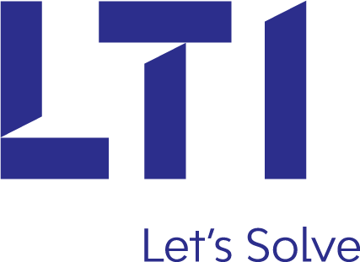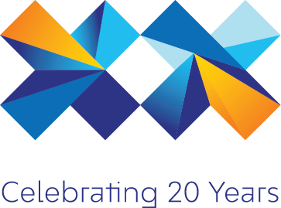

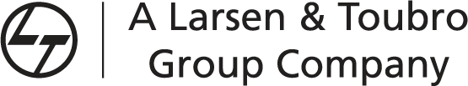

**MERN Stack Learning Path**

**Basic Level**

# Basic

* Basic requirement
* MERN Stack Tutorial
* Step 1: Draft ReactJS Application
* Step 2: Install React and ReactDOM
* Step 3: Make components folder.
* Possible Errors:
* Possible Solutions:
* Step 4: Create a form
* Possible Errors:
* Possible Solutions:
* Step 5: Make ItemService.js file
* Step 6: Make a nodejs express project.
* Step 7: Install expressjs framework
* Step 8: Make app.js file.
* Step 9: Install CORS Middleware
* Step 10: Make routes for our application.
* Step 11: Create mongoose schema.
* Possible Errors:
* Possible Solutions:
* Step 12: Register the routes at front end
* Step 13: Make editItem.js file.
* Step 14: Update the data.
* Step 15: Delete the data.
* Github Links
* Github Steps To Use MERN Stack Tutorial

## Learning Source

* <https://appdividend.com/2017/06/28/mern-stack-tutorial/>
* <https://facebook.github.io/react/docs/react-api.html>
* <https://docs.mongodb.com/manual/introduction/>
* <https://nodejs.org/en/docs/>
* <http://expressjs.com/en/api.html>